## Nielsen Heuristics Evaluation Form (make as many copies as you need)

**1. What screen of the UI are you looking at (attach/paste a picture/screenshot):**

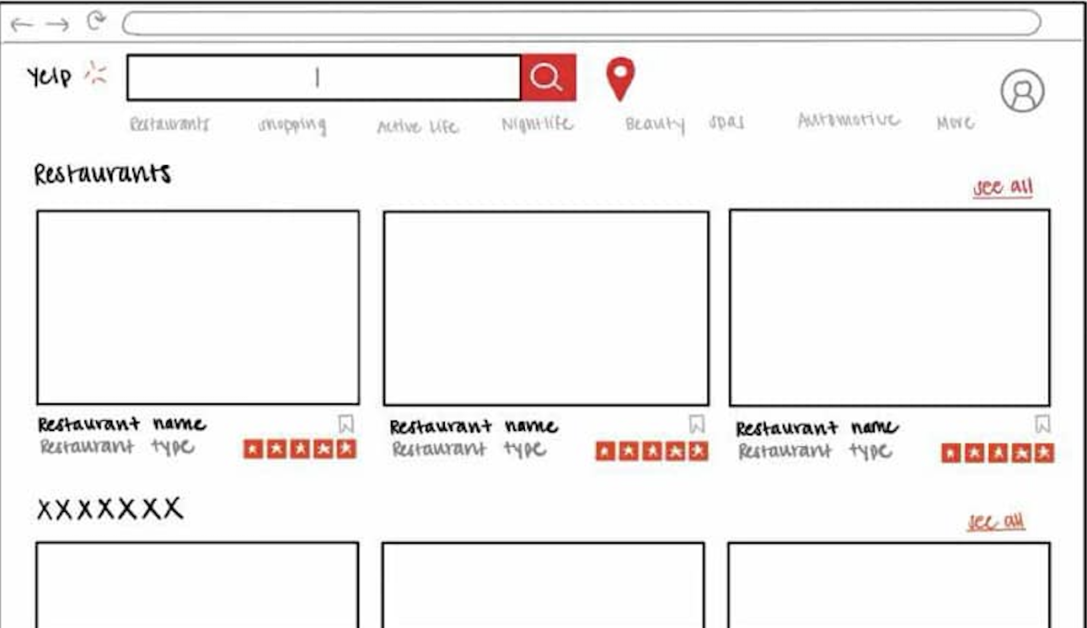

**2. Evaluate each heuristic below for this screen. Feel free to draw circles and arrows around the above screen shot.**

* Visibility of System Status:

**The interface provides feedback through visible search results for restaurants, ratings, and options to interact (e.g., saving a restaurant with a bookmark). However, there is no indication of loading status if search results are being fetched, which could leave users uncertain about system responsiveness.**

* Match Between System and Real World

**The design uses familiar concepts such as restaurant categories, star ratings, and a search bar, which align with real-world expectations for a restaurant-finding platform. Labels like "See All" further reinforce natural terminology.**

* User Control and Freedom

**The interface provides a search bar and clear options for navigation between categories (e.g., "Restaurants," "Nightlife," "Shopping"). However, there’s no visible undo functionality, such as removing a saved restaurant or resetting filters.**

* Consistency and Standards

**The design is consistent in its use of elements, such as rectangular tiles for restaurants and a uniform star rating system. However, the lack of clarity in the "See All" feature’s behavior across sections could cause some confusion.**

* Error Prevention

**The system minimizes potential errors by keeping its design simple and offering predefined categories and search capabilities. However, there is no mechanism to prevent invalid search inputs or notify users if their search yields no results.**

* Recognition Rather Than Recall

**The interface supports recognition by visually displaying restaurant options, categories, and ratings. Users don’t need to remember specific restaurant names or features to interact with the system effectively.**

* Flexibility and Efficiency of Use

**The interface appears beginner-friendly but doesn’t seem to offer advanced features for experienced users, such as filtering by additional attributes (e.g., price, distance). Adding filters could improve efficiency for power users.**

* Aesthetic and Minimalist Design

**The design is clean, with minimal distractions. Key information such as restaurant names, types, and ratings are prioritized. However, the layout could feel too sparse, and the large amount of whitespace might lead to inefficiency in using screen space.**

* Help Users Recognize, Diagnose, and Recover from Errors

**There is no visible support for error recovery. For instance, if a search returns no results, the system does not provide suggestions or corrective feedback.**

* Help and Documentation

**The interface lacks visible help or documentation. Users are not provided with instructions for using features like saving restaurants or understanding ratings. Adding a help section or tooltips would make the design more user-friendly.**